CLASSWORK 20 April 2020
URBANISATION
3.3 Read the article about urbanisation in FIGURE 3.3 and then answer the questions that follow.

3.3.1 | Define the term urbanisation. | (1 x 1) | (1)
3.3.2 | Name the percentage of the people living in urban areas in South
 | Africa. | (1 x 1) | (1)
3.3.3 | What are the causes of urbanisation in South Africa? | (2 x 1) | (2)
3.3.4 | Name FOUR problems associated with urbanisation. | (4 x 1) | (4)
3.3.5 | Refer to the 'bad' buildings in the article.
 | (a) Discuss TWO causes of 'bad' buildings. | (2 x 2) | (4)

- Suggest TWO possible solutions to the problem of 'bad'
buildings. | (2 x 2) | (4)
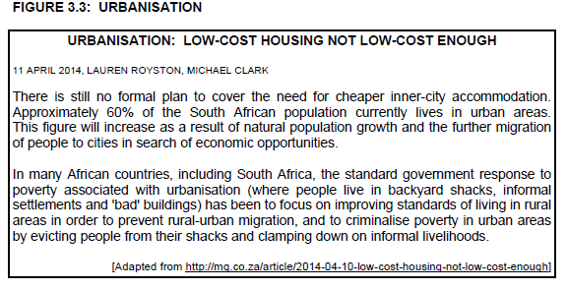
CLASSWORK 21 April 2020

Land use Zones:

3.4 Refer to FIGURE 3.4, (attached) showing a model of land-use zones.

3.4.1 | Which land-use model does FIGURE 3.4 show? | (1 x 2) | (2)
3.4.2 | Describe ONE feature of the land-use model mentioned in
 | QUESTION 3.4.1. | (1 x 2) | (2)
3.4.3 | Discuss THREE reasons why the CBDs of many South African
 | cities are losing their importance as central locations. | (3 x 2) | (6)
3.4.4 | State TWO differences between high- and low-income residential
 | zones evident in South African cities. | (2 x 2) | (4)
3.4.5 | Write a paragraph (approximately 12 lines), explaining some of
 | the factors that influence the location of land-use zones in a
 | modern city. | (6 x 2) | (12)

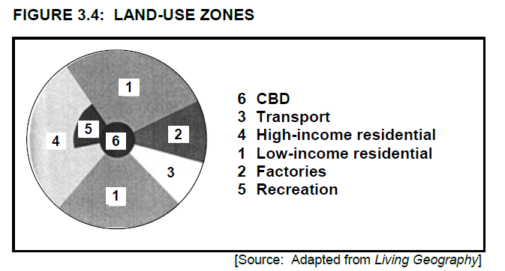

CLASSWORK 22 April 2020
URBAN SPRAWL
4.4 Study FIGURE 4.4 showing urban sprawl in an urban settlement from 1980 to 2020.

 | 4.4.1 | Define the term urban sprawl. | (1 x 1) | (1)
 | 4.4.2 | Describe the effect of urban sprawl on housing density in this urban
 |  | settlement. | (1 x 1) | (1)
 | 4.4.3 | Give a possible reason why area A was not used for urban
 |  | development in 1980. | (1 x 2) | (2)
 | 4.4.4 | (a) Which street pattern would be most suitable for area A in the
 |  | diagram for 2020? | (1 x 2) | (2)
 |  | (b) Give ONE reason for your answer to QUESTION 4.4.4(a).
 |  |  | (1 x 2) | (2)
 | 4.4.5 | In a paragraph of approximately EIGHT lines, evaluate the effect
 |  | that urban sprawl will have on the natural environment at A in 2020.
 |  |  | (4 x 2) | (8)
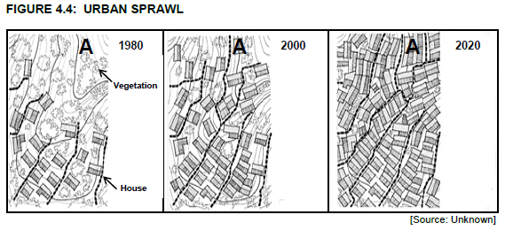

CLASSWORK 23 April 2020
LAND USE ZONE ( Classification of Urban areas)

4.4 Refer to the land-use model in FIGURE 4.4.

4.4.1 | Name the land-use model in FIGURE 4.4. | (1 x 1) | (1)
4.4.2 | Is the residential land-use zone at C a low-, middle- or high-income
 | area? | (1 x 1) | (1)
4.4.3 | Explain why the land value at A is high. | (2 x 2) | (4)
4.4.4 | Give a reason why the industrial zone and zone B are not
 | compatible. | (1 x 2) | (2)
4.4.5 | In a paragraph of approximately EIGHT lines, analyse how this
 | model compares with a typical South African city. | (4 x 2) | (8)
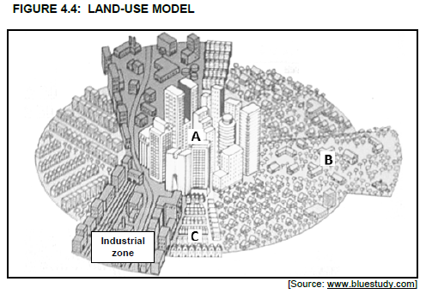
HOMEWORK 23 April 2020
4.4 FIGURE 4.4 shows a simplified model and land-use zones of a city in South Africa.

4.4.1 | Name land-use zone A. | (1 x 1) | (1)
4.4.2 | Give a possible reason why the transition zone (B) doesn't fully
 | enclose zone A. | (1 x 2) | (2)
4.4.3 | Why is land-use zone D likely to be a low-income residential area?
 |  | (1 x 2) | (2)
4.4.4 | State ONE factor that would have promoted the location of
 | shopping centre C. | (1 x 2) | (2)
4.4.5 | Write a paragraph of approximately EIGHT lines in which you
 | discuss the negative factors in land-use zone A that resulted in the
 | relocation of businesses to C and its surrounding area. | (4 x 2) | (8)
